E-Commerce Analysis SQL Documentation

DATA QUALITY CHECK FOR customers table
SELECT
COUNT(*) AS total_rows,
COUNT(DISTINCT Customer_ID) AS unique_customers
FROM customers;
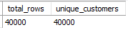

ALTER TABLE customers
MODIFY COLUMN Date_of_Birth DATE,
MODIFY COLUMN Registration_Date DATE;

-- DATA QUALITY CHECK for products table
SELECT
COUNT(*) AS total_rows,
COUNT(DISTINCT Product_ID) AS unique_products
FROM products;
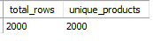

DATA QUALITY CHECK for sales table
SELECT
COUNT(*) AS total_rows,
COUNT(DISTINCT Order_ID) AS unique_orders
FROM sales;
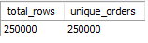

UPDATE sales
SET Order_Date = STR_TO_DATE(Order_Date, "%m/%d/%Y");

UPDATE sales
SET Delivery_Date = STR_TO_DATE(Delivery_Date, "%m/%d/%Y");

ALTER TABLE sales
MODIFY COLUMN Order_Date DATE,
MODIFY COLUMN Delivery_Date DATE;

UPDATE sales
SET Rating = NULL
WHERE Rating = '';

ALTER TABLE sales
MODIFY COLUMN Rating INT NULL;

UPDATING BLANK VALUES IN COLUMNS WITH FRIENDLY MESSAGE
UPDATE sales
SET Coupon_Code = 'No coupon used'
WHERE Coupon_Code IS NULL OR Coupon_Code = '';

UPDATE sales
SET Review_Text = 'No written review left'
WHERE Review_Text IS NULL OR Review_Text = '';

SELECT
MIN(Order_Date) AS earliest_order,
MAX(Order_Date) AS latest_order
FROM sales;
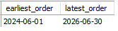

PART 1: OVERVIEW & MACRO KPIs

1. High-Level Counts: Total Unique Orders, Active Customers (with Purchases), and Products Sold in Sales
SELECT
COUNT(DISTINCT Order_ID) AS total_unique_orders,
COUNT(DISTINCT Customer_ID) AS total_unique_customers,
COUNT(DISTINCT Product_ID) AS total_unique_products
FROM sales;
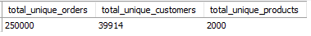

2. Order Status Breakdown: Total Sales Value across all Order Lifecycle Stages
SELECT
SUM(CASE WHEN Order_Status = 'Delivered' THEN Total_Amount ELSE 0 END) AS total_sales,
SUM(CASE WHEN Order_Status = 'Returned' THEN Total_Amount ELSE 0 END) AS refunded_sales,
SUM(CASE WHEN Order_Status = 'Cancelled' THEN Total_Amount ELSE 0 END) AS lost_sales,
SUM(CASE WHEN Order_Status = 'Processing' THEN Total_Amount ELSE 0 END) AS processing_sales,
SUM(CASE WHEN Order_Status = 'Shipped' THEN Total_Amount ELSE 0 END) AS pending_sales,
SUM(Total_Amount) AS gross_potential_sales
FROM sales;

PART 2: REALIZED REVENUE (Delivered Orders Only)

1. Core Performance KPIs: Total Sales, Delivered Orders, and Average Order Value (AOV)
SELECT
SUM(Total_Amount) AS total_sales,
COUNT(DISTINCT Order_ID) AS total_orders,
SUM(Total_Amount) / COUNT(DISTINCT Order_ID) AS avg_order_value
FROM sales
WHERE Order_Status = 'Delivered';
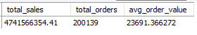

2. Sales Performance by Product Category (with percentage contribution)
SELECT
p.Category,
SUM(s.Total_Amount) AS total_sales,
ROUND((SUM(s.Total_Amount) / (SELECT SUM(Total_Amount) FROM sales WHERE Order_Status = 'Delivered')) * 100, 2) AS sales_percentage
FROM sales AS s
INNER JOIN products AS p
ON s.Product_ID = p.Product_ID
WHERE s.Order_Status = 'Delivered'
GROUP BY p.Category
ORDER BY total_sales DESC;
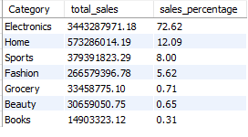
3. Top 10 Best-Performing Brands by Sales Revenue
SELECT
p.Brand,
SUM(s.Total_Amount) AS total_sales
FROM sales AS s
INNER JOIN products AS p
ON s.Product_ID = p.Product_ID
WHERE s.Order_Status = 'Delivered'
GROUP BY p.Brand
ORDER BY total_sales DESC
LIMIT 10;
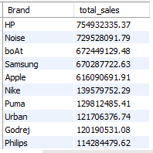

4. Monthly Revenue Trend and Month-over-Month (MoM) Growth Analysis
SELECT
DATE_FORMAT(Order_Date, "%Y-%m") AS `year_month`,
COUNT(Order_ID) AS total_orders,
SUM(Total_Amount) AS monthly_sales,
LAG(SUM(Total_Amount)) OVER(ORDER BY DATE_FORMAT(Order_Date, "%Y-%m")) AS previous_month_sales,
SUM(Total_Amount) - LAG(SUM(Total_Amount)) OVER(ORDER BY DATE_FORMAT(Order_Date, "%Y-%m")) AS MoM_growth,
ROUND((SUM(Total_Amount) - LAG(SUM(Total_Amount)) OVER(ORDER BY DATE_FORMAT(Order_Date, "%Y-%m"))) * 100
/ LAG(SUM(Total_Amount)) OVER(ORDER BY DATE_FORMAT(Order_Date, "%Y-%m")),2) AS MoM_growth_pct
FROM sales
WHERE Order_Status = 'Delivered'
GROUP BY `year_month`
ORDER BY `year_month`;

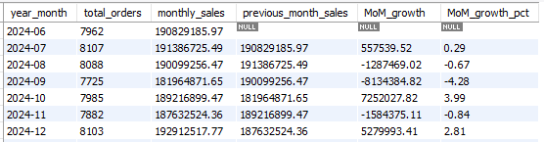
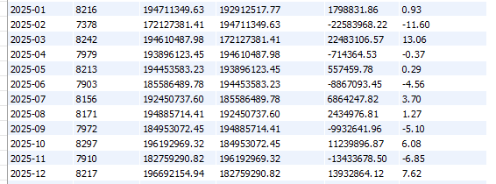
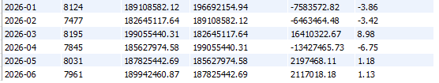

5. Geographic Performance: Top States by Sales Revenue and Unit Volume
SELECT
State,
COUNT(DISTINCT Order_ID) AS total_orders,
SUM(Quantity) AS total_sold_units,
SUM(Total_Amount) AS total_sales
FROM sales
WHERE Order_Status = 'Delivered'
GROUP BY State
ORDER BY total_sales DESC;
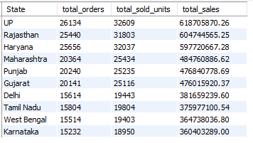

6. Customer Segmentation: Revenue Contribution Share by Customer Tier
SELECT
c.Customer_Tier,
SUM(s.Total_Amount) AS total_sales,
ROUND((SUM(s.Total_Amount)*100) / (SELECT SUM(Total_Amount) FROM sales WHERE Order_Status = 'Delivered'),2) AS sales_pct
FROM sales AS s
INNER JOIN customers AS c
ON s.Customer_ID = c.Customer_ID
WHERE s.Order_Status = 'Delivered'
GROUP BY c.Customer_Tier
ORDER BY total_sales DESC;
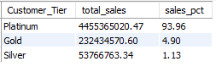

7. Customer Demographics: Sales Performance by Age Group
SELECT
Customer_Age_Group,
COUNT(DISTINCT Order_ID) AS total_orders,
SUM(Quantity) AS total_quantity_sold,
SUM(Total_Amount) AS total_sales
FROM sales
WHERE Order_Status = 'Delivered'
GROUP BY Customer_Age_Group
ORDER BY total_sales DESC;
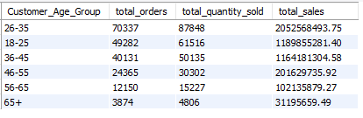

8. Payment Preferences: Transaction Volume and Revenue Share by Payment Mode
SELECT
Payment_Mode,
COUNT(DISTINCT Order_ID) AS total_orders,
SUM(Quantity) AS total_quantity_sold,
SUM(Total_Amount) AS total_sales,
ROUND((SUM(Total_Amount) * 100) / (SELECT SUM(Total_Amount) FROM sales WHERE Order_Status = 'Delivered'),2) AS sales_pct
FROM sales
WHERE Order_Status = 'Delivered'
GROUP BY Payment_Mode
ORDER BY total_sales DESC;
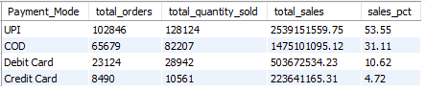

9. Top 10 Customers by Realized Revenue
SELECT
c.Customer_ID,
c.Customer_Name,
c.Customer_Tier,
COUNT(DISTINCT s.Order_ID) AS total_orders,
SUM(s.Total_Amount) AS total_sales
FROM sales AS s
INNER JOIN customers AS c
ON s.Customer_ID = c.Customer_ID
WHERE s.Order_Status = 'Delivered'
GROUP BY c.Customer_ID, c.Customer_Name, c.Customer_Tier
ORDER BY total_sales DESC
LIMIT 10;
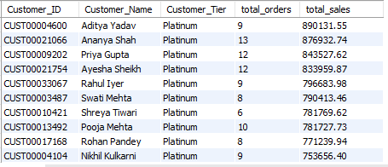

PART 3: PRODUCT & INVENTORY INSIGHTS

1. Top 10 Best-Selling Products (Ranked by Units Sold)
WITH cte AS
(
SELECT
p.Product_ID,
p.Product_Name,
p.Stock_Quantity,
SUM(s.Quantity) AS total_units_sold
FROM products AS p
INNER JOIN sales AS s
ON p.Product_ID = s.Product_ID
WHERE s.Order_Status = 'Delivered'
GROUP BY p.Product_ID, p.Product_Name, p.Stock_Quantity
),
ranked_cte AS
(
SELECT
*,
ROW_NUMBER() OVER(ORDER BY total_units_sold DESC) AS unit_rank
FROM cte
)
SELECT *
FROM ranked_cte
WHERE unit_rank <= 10
ORDER BY unit_rank ASC;
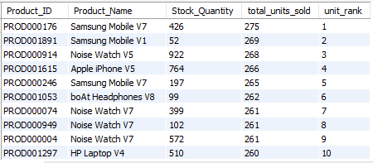

2. Gross Revenue & Total Units Sold by Discount Bracket
SELECT
CASE
WHEN p.Discount_Percent BETWEEN 0 AND 10 THEN '0-10%'
WHEN p.Discount_Percent BETWEEN 11 AND 25 THEN '11-25%'
WHEN p.Discount_Percent BETWEEN 26 AND 50 THEN '26-50%'
END AS discount_brackets,
SUM(s.Total_Amount) AS total_sales,
SUM(s.Quantity) AS total_units_sold
FROM products AS p
INNER JOIN sales AS s
ON p.Product_ID = s.Product_ID
WHERE s.Order_Status = 'Delivered'
GROUP BY discount_brackets
ORDER BY total_sales DESC;
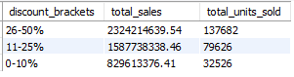

PART 4: OPERATIONS & LOGISTICS PERFORMANCE

1. Supply Chain Audit: Average Delivery Lead Time by State
SELECT
State,
COUNT(DISTINCT Order_ID) AS total_orders_delivered
FROM sales
WHERE Order_Status = 'Delivered'
GROUP BY State
ORDER BY total_orders_delivered DESC;
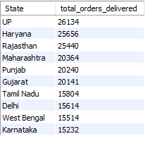

2. Total Orders Delivery Speed Tiers
WITH delivery_days AS
(
SELECT
Order_ID,
DATEDIFF(Delivery_Date, Order_Date) AS days_delivered,
Total_Amount
FROM sales
WHERE Order_Status = 'Delivered'
)
SELECT
CASE
WHEN days_delivered <= 3 THEN 'Fast (1-3 Days)'
WHEN days_delivered BETWEEN 4 AND 5 THEN 'Standard (4-5 Days)'
ELSE 'Slow (6+ Days)'
END AS delivery_speed_tier,
COUNT(DISTINCT Order_ID) AS total_orders
FROM delivery_days
GROUP BY delivery_speed_tier;
